Compile

-make

-./output

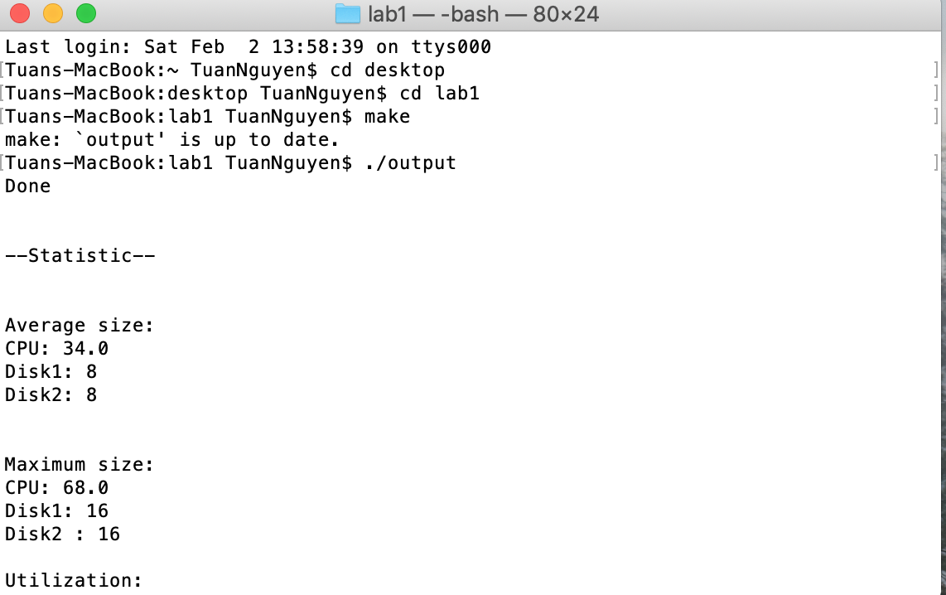

Test 1

-value in config.txt

SEED 0

INIT_TIME 0

FIN_TIME 1000

ARRIVE_MIN 10

ARRIVE_MAX 40

QUIT_PROB .2

CPU_MIN 10

CPU_MAX 20

DISK1_MIN 10

DISK1_MAX 30

DISK2_MIN 10

DISK2_MAX 30

-result in out.txt

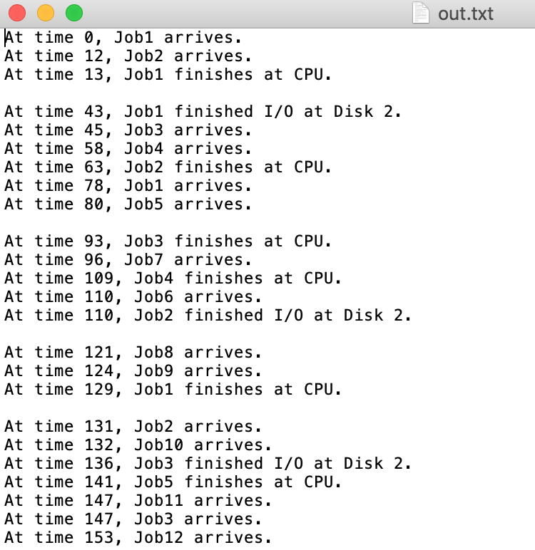

Test 2

SEED 2

INIT_TIME 0

FIN_TIME 3000

ARRIVE_MIN 20

ARRIVE_MAX 60

QUIT_PROB .5

CPU_MIN 20

CPU_MAX 60

DISK1_MIN 30

DISK1_MAX 50

DISK2_MIN 30

DISK2_MAX 50

-in out.txt

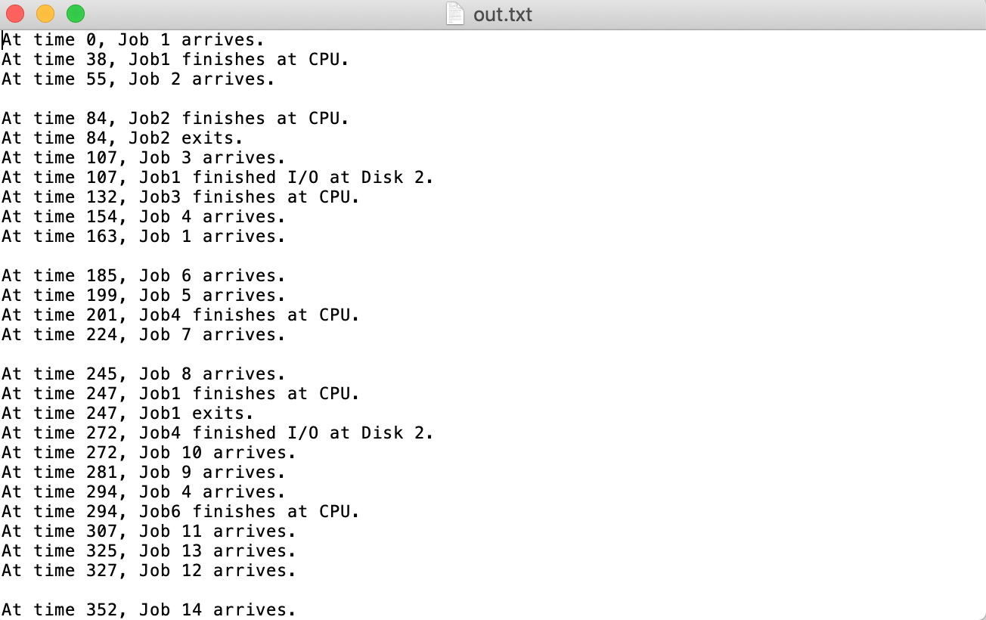

test 3

SEED 4

INIT_TIME 0

FIN_TIME 6000

ARRIVE_MIN 1

ARRIVE_MAX 60

QUIT_PROB .5

CPU_MIN 1

CPU_MAX 60

DISK1_MIN 40

DISK1_MAX 60

DISK2_MIN 40

DISK2_MAX 60

-in out.txt

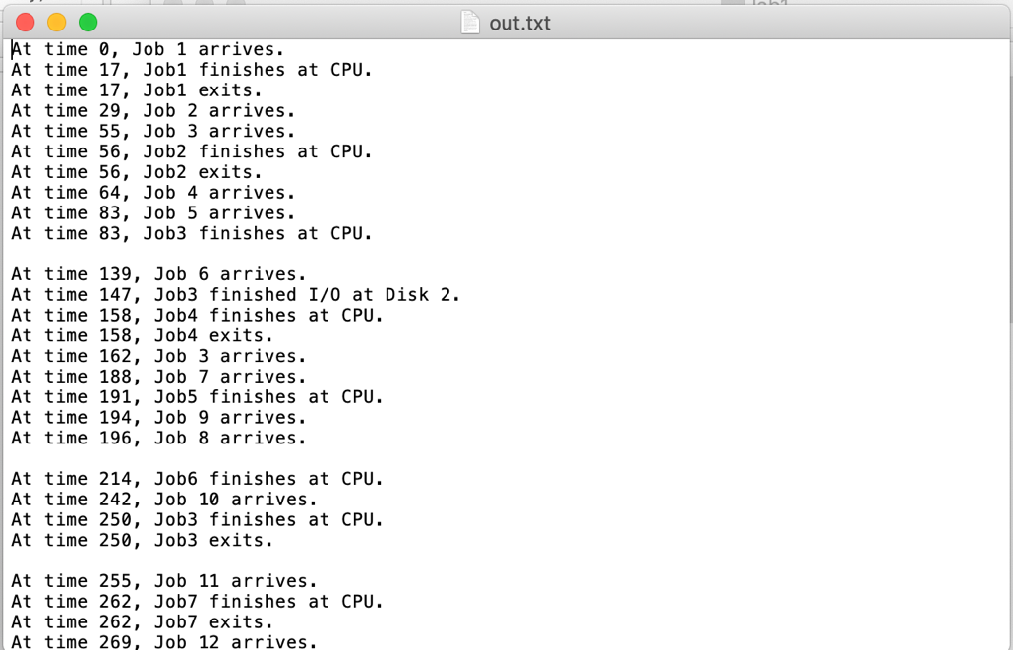

test 4

SEED 8

INIT_TIME 0

FIN_TIME 10000

ARRIVE_MIN 1

ARRIVE_MAX 100

QUIT_PROB .7

CPU_MIN 1

CPU_MAX 50

DISK1_MIN 1

DISK1_MAX 50

DISK2_MIN 1

DISK2_MAX 50

-in out.txt

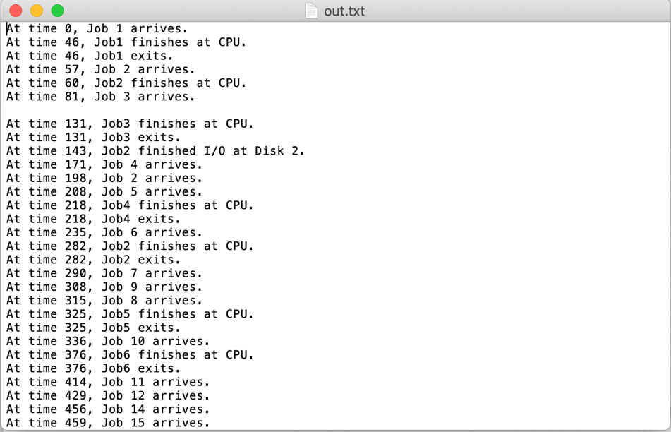

test 5

SEED 9

INIT_TIME 0

FIN_TIME 10000

ARRIVE_MIN 1

ARRIVE_MAX 50

QUIT_PROB .5

CPU_MIN 1

CPU_MAX 70

DISK1_MIN 1

DISK1_MAX 70

DISK2_MIN 1

DISK2_MAX 70

-in out.txt

